**FOToD** 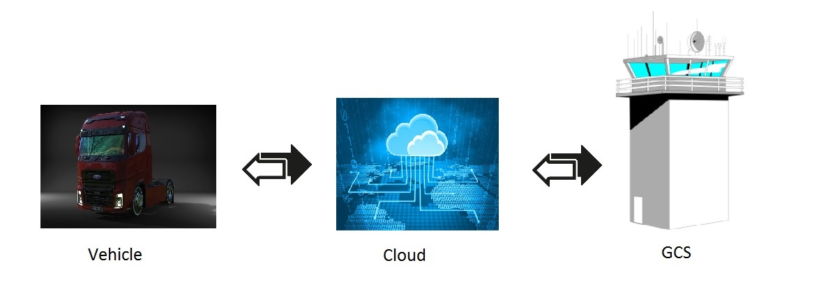

**ABSTRACT**

Here, we present an open-source cloud (4G) connected and controlled Vehicle system. The Vehicle part is including the controller (Omnibus F4), 4G cellular data modem, and on-board companion Linux computer (Raspberrypi).

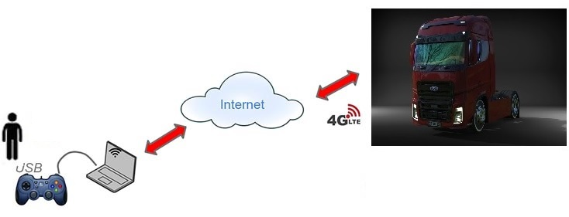

**There are three main part;**

* Mavlink-router
* Webcam
* 4G cellular data modem

**Mavlink-router**

This is the idea of the project, and connects the vehicle to a Ground Control Station over the internet From every place.

It uses a cloud server stabilize, and coordinate all communications. And mavlink-router provide this connectiotion.

**Webcam**

An HD Pi camera can provide video, which it necessary to use vehicle from Ground Control Station.

**4G cellular data modem**

An a 4G modem provide internet connection.

**How it works**

The Vehicle Pi "calls" the cloud AWS server on reverse ssh. The Win or Linux ground station "calls" the AWS server on reverse ssh.

